Jenkins build history:

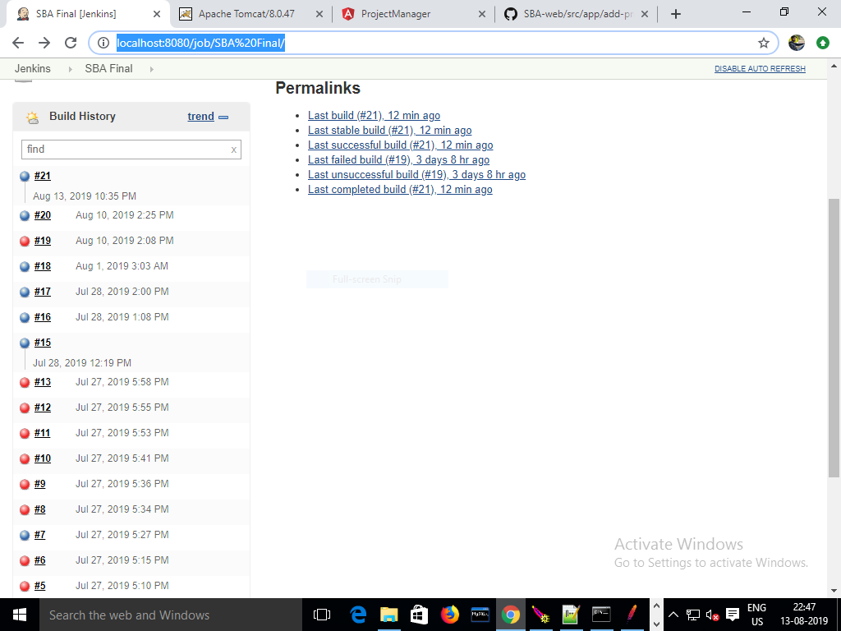

Jenkins console output:

